Electric Circuits
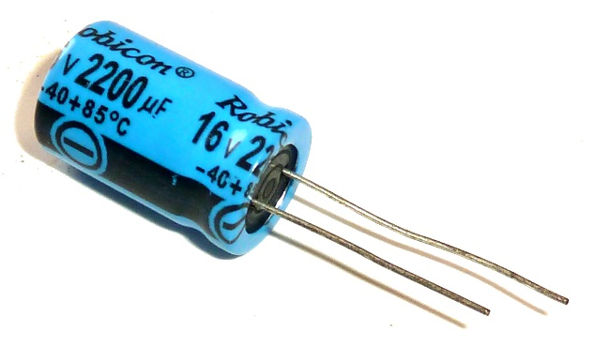
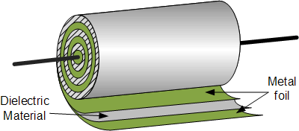
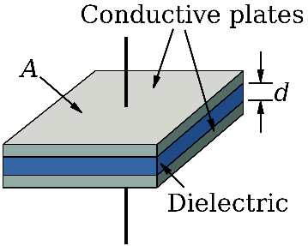

With the voltage sensor on the PASCO unit you can record voltage as a function of time.
Practically, if you only want to measure a static voltage, a multimeter is much more convenient. 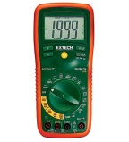
So, the PASCO probe only makes sense when our experiment produces changing voltages like:

Charging and discharging a capacitor:
A capacitor is somewhat similar to a rechargeable battery. However, it works without the chemistry inside a battery – a cap is purely electric [okay, there are electrolytic caps which have some chemistry inside].
The capacitance C tells us how much charge Q we can store on it relative to the applied voltage ΔV. In that sense it is kind of elastic, the higher the voltage [the harder we press] the more charge we get into it – just like a drawer with socks which takes more if we press harder.
$$C=\frac{Q}{∆V}=ε_{0}A/d$$

Experiments
Let’s charge the capacitor. Probably, we want to connect it to the battery.
How quickly, do you think, it will be filled?
What could we do to make it charge slower?
How can we tell [or better: how can we measure], how much charge we have on the capacitor?
Ok, now the cap is full – let’s drain/discharge it – drain it through the lamp bulb and observe the brightness.
Was it draining with a steady current?
Try to sketch the current as a function of time.
[Using the lamp bulb is convenient for observation but has one major disadvantage: its resistance varies with the temperature of the filament, thus messing with the discharge rate.]
Use the PASCO probe to monitor the voltage on the cap as you drain its charge.
We better use a standard resistor for this.
[This voltage is directly proportional to WHAT?]
How can we influence the drainage rate?
Try it out.
How are the charge on the cap and the drainage current related?
What is driving the current?
What reduces the charge on the cap?

Other examples of Exponential Decay Laws [from Wikipedia]:
- Beer froth: – Arnd Leike, of the Ludwig Maximilian University of Munich, won an Ig Nobel Prize for demonstrating that beer froth obeys the law of exponential decay.
- Chemical reactions: The rates of certain types of chemical reactions depend on the concentration of one or another reactant. Reactions whose rate depends only on the concentration of one reactant (known as first-order reactions) consequently follow exponential decay. For instance, many enzyme-catalyzed reactions behave this way.
- Atmospheric pressure decreases approximately exponentially with increasing height above sea level, at a rate of about 12% per 1000m.
- Pharmacology and toxicology: It is found that many administered substances are distributed and metabolized according to exponential decay patterns. The biological half-lives of a substance measure how quickly a substance is distributed and eliminated.
- Physical optics: The intensity of X-rays in an absorbent medium, follows an exponential decrease with distance into the absorbing medium. This is known as the Beer-Lambert law.

Don’t push too hard, though - every cap has a voltage limit.

