Simple Electrical Circuits

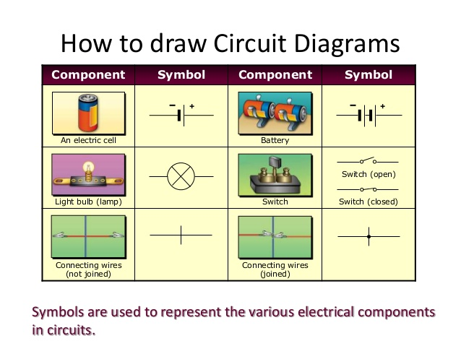
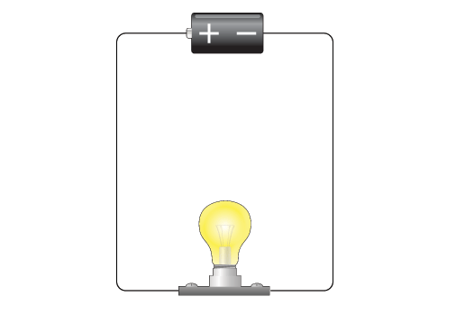
In this activity we will explore simple circuits involving batteries and resistors (light bulbs).
Simple circuit
Figure how to make a bulb light up. How many wires do you need?
What is essential to form a circuit – why might it be named “circuit”?
Sketch your circuit below using the symbols on page 1. Is there a continuous path for the current to flow from one side of the battery to the other side? If so, then trace the current path.
What do you predict will be the
- Voltage across the battery?
- Voltage across the lamp?
- Voltage across one of the cables?
Take the multimeter and measure each of these voltages.
Does it match your predictions?
Now add a second battery!
Which options do you have to add the battery?
Predict the effect of each option!
Try it out – predict / build it / measure / explain!

Circuits in series and parallel

Consider a circuit containing a battery and two light bulbs in series and another circuit containing a battery and two light bulbs in parallel.
Which situation is shown here on the right?

Build such a circuit!
What do you predict will be the
- Voltage across the battery?
- Voltage across each lamp?
- Voltage across both lamps?
- Voltage across one of the cables?
Take the multimeter and measure each of these voltages.
Does it match your predictions?
What will happen if you unscrew one of the bulbs?
Which voltage do you expect to find across the remaining light bulb?
Which voltage do you expect to find across the empty light bulb socket?

Now add a second battery!
Which options do you have to add the battery?
Predict the effect of each option!
Try it out – predict / build it / measure / explain!

Now build a circuit with 2 bulbs in parallel!
What do you predict will be the
- Voltage across each lamp?
- Voltage across both lamps?
Take the multimeter and measure each of these voltages.
Does it match your predictions?
What will happen if you unscrew one of the bulbs?

Which of the 2 circuit, series and parallel, should produce more light?
Explain your thoughts and compare against your observations!

Resources:
Resistor Combinations
Two resistors can be connected either in series or in parallel, as shown below.

The addition rules for the equivalent resistance are
Series: Parallel:
Using a multimeter:
The diagram to shows how to insert the multimeter into the circuit to measure voltage and current.
Caution: Don’t place the multimeter in the ammeter setting directly across the battery and resistor. It will draw excessive current which may result in a blown fuse or damaged meter.

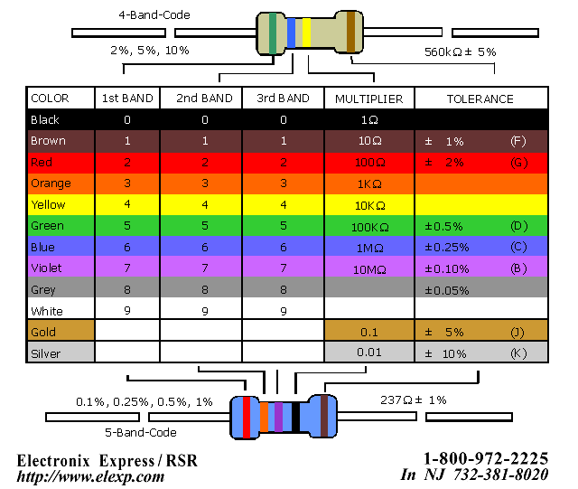
Resistor Color Code

