Acids and Bases
pH value experiments

2 H₂O H₃O⁺ + OH⁻
$$\frac{\left[H_{3}O^{+}\right]x[OH^{-}]}{{[H_{2}O]}^{2}}=constant$$
[H₃O⁺] [OH⁻] = const. = 10⁻¹⁴ (mol/l)²

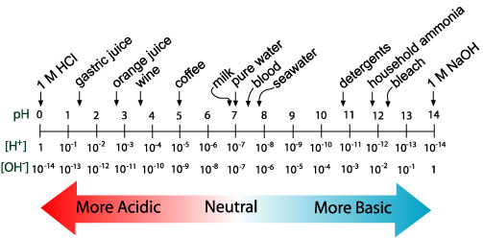

Doing the numbers – calculating the pH value
Keep the solution with the dissolved Na.
What should be in the solution? What were the reactants?
Do you expect it to be acidic or basic?
What should be the pH value?
Well, each Na atom upon reaction with water created one [OH]⁻ ion.
If we reacted 1 mm³ of Na, having a density of approximately 1g/cm³ we had how many grams of Na?
With 23g Na being one mol, thus we had how many moles of Na, equaling the mols [OH]⁻ created?
pH value expected:
Take a measurement
pH value measured:

Now add another 1 mm³ of Na.
Which new pH value do you expect? Big change?
Take a measurement. Big change?

Neutralization / Titration
Now carefully add some vinegar, frequently stirring, and watch the pH go down.
You neutralize the NaOH base.
Continue till you reach approximately pH4, thus making the solution acidic.
Now we approximately have as many excess H₃O⁺ ions as we had OH⁻ ions before, right?
So adding one more bit of 1 mm³ Na should neutralize this bringing the pH back to neutral pH7, right?
Try it and think of an explanation of what you observe.
Think biology – this effect plays a large role in living things.

