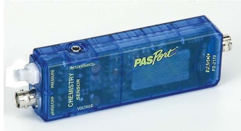 Pressure Sensor
With the pressure sensor part of the PASCO Chemistry Sensor unit (2170) you can undertake several experiments like:
Boyle’s Law which we did last time:
Attach the syringe and watch/record the pressure while compressing the gas in the syringe.
This way you can quickly demo to a class Boyle’s Law. (Note: For an accurate analysis of the Boyle's law experiment, you need to take into account the volume of air in the tube as well as the syringe.)
Hydrostatic pressure
You can use it to measure the pressure under water as you dive deeper. Ok, you need to keep the sensor dry, so attach one end of the plastic tube to the sensor and put a moderately inflated balloon around the other end and tape it tight. (You can get even longer ¼” tubes if needed from BigBox stores.) The balloon will be your pressure sensor, so you measure pressure at the depth in the water where the balloon is.
Now push the balloon under water and record pressure as a function of depth.
Air pressure
Air pressure is pretty much the same as hydrostatic pressure with only 2 complications.
First, we live at the bottom of the (air-) pool; Second the density of air varies, so the pressure variation with height is not linear.
The sensor is capable of sensing the difference between pressure near the ceiling and near ground.
For larger changes in pressure, climb some stairs or record a drive along a hilly road, or, ....
You can also try your lungs – how much over-pressure or vacuum they can produce.
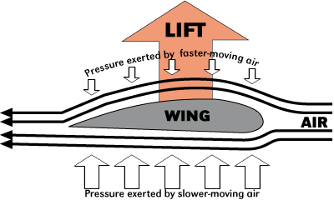
Bernoulli’s Law
This is the strange effect which keeps air planes afloat. The faster the air flow, the lower the pressure. You can blow through a pipe with the sensor tubing attached on the side [just drill a ¼” hole] and watch the pressure. Needs a good blow / narrow enough pipe.

Pasco Chemistry Sensor 2170

Overview
Gas laws, acid/base, thermochemistry and redox all with one sensor! Measure temperature, pH, absolute gas pressure and voltage. Easy to store, easy to use. All measurements can be made simultaneously.

Typical Applications
- Explore Gas Laws
- Perform Acid/Base Investigations
- Study Endothermic and Exothermic Reactions
- Determine an Electrochemical Series

Includes
• Stainless Steel Temperature Probe
• pH Probe
• Voltage Probe
• Polyurethane Tubing (60 cm long)
• Quick-release Connectors (4)
• Tubing Connectors (4)
• 60 cc Syringe

