**Optics**

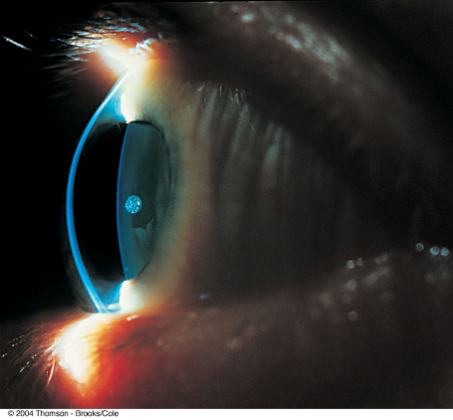**Ray Optics**

Image Formation

Online resources:

<https://phet.colorado.edu/en/simulation/legacy/geometric-optics>

<http://www.walter-fendt.de/html5/phen/imageconverginglens_en.htm>

<https://pages.physics.ua.edu/faculty/schad/teaching/LABs/CH36%20Geometric%20optics/CH36%20SWF%20image%20lens.swf>

1. Use the optics kit, take a ray source and send a ray through one of the “flat” lenses.  
   What do you observe?  
   Try center and off-center rays.  
   Remembering Snell’s Law, do you find the direction the light takes in accordance with this law?  
   Trace the outline of a lens and the rays on paper.  
   How does this change using different lenses?  
   Which lens would you call a converging lens and which a diverging lens?
2. Light up the candle, take a circular lens and form an image on a sheet of paper!
3. Which lens works, which one does not? Why?
4. Draw a ray diagram for the image you formed using the lens which works!
5. Now take the lens which did not work and look straight through it at the candle flame – can you see the flame? If yes, an image is formed on your eyes’ retinae.   
   So, why is an image formed in this case?
6. Use the "Geometric Optics" PhET simulation (or the walter-fendt converging lenses html5 simulation if using an iPad) to explore image formation. How does the simulation compare with your observations for the lens that forms an image on the screen? (e.g., dependence of size, orientation, and position of the image on position of the candle.)

Focal Length

Every lens has a 'focal length'. For a 'converging' lens like the one that you used above to generate an image on a screen, it is the distance from the image to the lens when the object is very far away. First use a “flat” lens and all 3 (red, green, blue) rays held parallel. Where is the focal point?  
Repeat this for the “flat” diverging lens – trace the lens and the rays on paper. Where is the focal point?

Try to measure the focal length of your regular circular lens by imaging a distant bright object such as the projection screen in the room.

The focal length allows you to calculate the image distance when you know the object distance using the formula

,

where *do, di,* and *f* are the object distance, image distance, and focal length, respectively.

Re-adjust the candle position to get an image on the small screen and use the above equation to calculate *f*. How does this compare with your previous determination of *f*?

**Diffraction**

1. 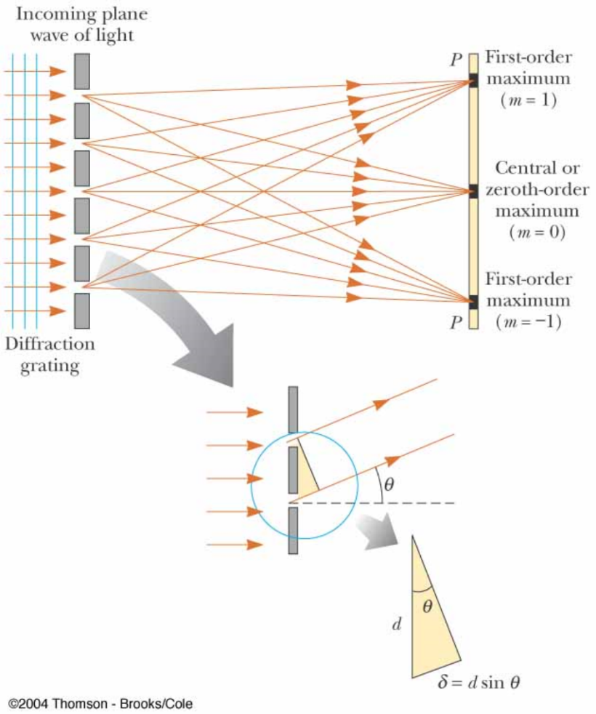Create a diffraction pattern using the red laser and the diffraction grating.  
   Now use the green laser and then the blue one. What differences do you observe?  
     
   Given *m* * = d sin , (m* = 0, ±1, ±2, ...)  
   what are the meaning of m, , d, ?  
   Does your observation make sense?
2. If you have a laser pointer and a piece of a CD or DVD you can use them to form a diffraction pattern. Calculate the track spacing of the CD using the equation below.

 (m = 0, ±1, ±2, …)

