n | PS-21 Concept Test – Optics
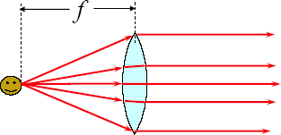
What will happen to the rays emerging to the right of the lens if the face is moved a little closer to the lens?
- They will remain parallel.
- They will diverge (spread out).
- They will converge (toward a focus).

What will happen to the rays emerging to the right of the lens if the face is moved a little further away from the lens?
- They will remain parallel.
- They will diverge (spread out).
- They will converge (toward a focus).

A ray of light strikes the underside of a plate of glass surrounded by air. Which set of rays best illustrates the light as it travels through the plate.

A
B
C
D
E

What property of a diffraction grating determines the spread of the diffraction pattern you see when you view light through the grating?
a) the width of the grating
b) the total number of lines in the grating
c) the color of the grating
d) the thickness of the grating
e) the separation of adjacent lines in the grating
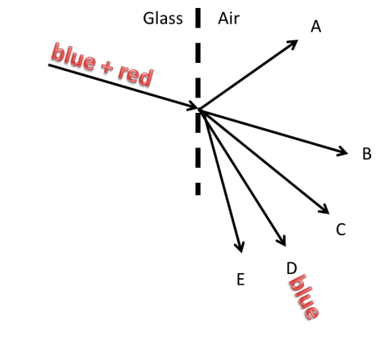
Two light beams, a blue and a red, travel together through a glass prism and hit its surface [dashed line] as shown.
Outside in air, the blue beam takes the direction D as shown.
In glass: n_{blue} > n_{red} > 1; In air: n_{blue} = n_{red} = 1
Which will be the approximate direction the red beam will take?

- A, new direction, bent upwards
- B, keeps going straight
- C, new direction, less bent than blue
- D, new direction, same direction as blue
- E, new direction, more bent than blue

You use a converging lens to form an image of a distant tree on a sheet of paper. This image is
a) real and upright
b) real and inverted
c) virtual and upright
d) virtual and inverted

Light in medium 1 is incident at an angle of 60º with a surface interfacing medium 2 as shown. The angle the light ray makes with the normal in medium 2 is θ < 60º. What can be concluded?
- The critical angle for this interface is 60º
- n₁ = n₂
- n₁ > n₂
- n₁ < n₂
- n₂ = 1.0
Using a diffraction grating with either a green or a red light beam, the diffraction patterns will be:
- Identical [except for the color]
- Farther spread out for the green light than the red light
- Farther spread out for the red light than the green light
- Only red light can form a diffraction pattern

