Lemon Battery

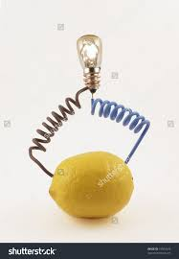

Zn
Cu
V

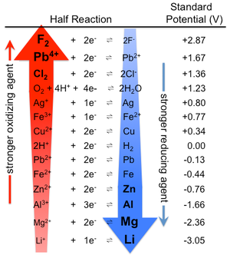
We probably all have fond memories of those lemon, potato or apple batteries.
Do they actually work?
Build one! Which metals would you use?
Which fruit or vegetable should be best?
Measure with the multimeter the voltage output.
Measure with the multimeter the maximum current it can deliver.
Do you expect your battery to be able to deliver maximum voltage and maximum current at the same time?
Use a second multimeter and check.
What do you find / what could be an explanation?

Now we want to light up a LED [they are so much more energy efficient than a regular light bulb, so we actually have a chance]
The red LED needs a minimum voltage of about 1.5V to operate.
We probably need multiple lemon batteries – make more or talk to the neighbor groups.
Would you rather connect them in series or in parallel?
Which output voltage to you find for the two different configurations?
What is the maximum current in each case?
What will work?

Zn
Cu
Zn
Cu
Zn
Cu
LED
Zn
Cu
LED
Zn
Cu
Zn
Cu

