Capacitors
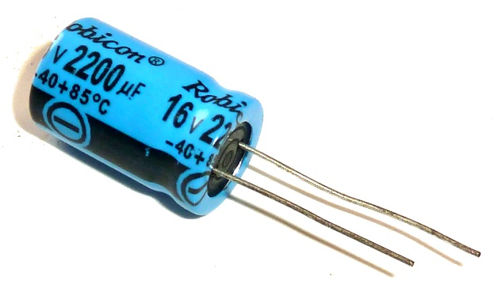
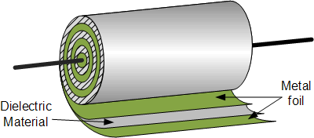
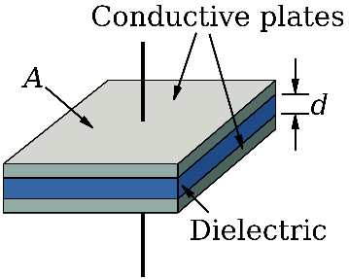

Charging and discharging a capacitor:
A capacitor is somewhat similar to a rechargeable battery. However, it works without the chemistry you have inside a battery – a capacitor is purely electric.
The capacitance C tells us how much charge Q we can store on it relative to the applied voltage ΔV. In that sense it is kind of elastic, the higher the voltage [the harder we press] the more charge we get into it – just like a drawer filled with socks which accepts more socks if we press harder.
$$C=\frac{Q}{∆V}=ε_{0} \frac{Area}{distance_between_plates}$$

Experiments
Let’s charge the capacitor using the hand crank generator. Use the multimeter to measure the voltage produced by the generator. Note that the polarity of the output depends on the direction that you crank (clockwise or counter-clockwise). (You can keep track of the polarity by noting that the wires from generator differ in color - gold or silver).
Examine the labeling on the capacitor. In addition to the value of the capacitance (1 Farad), it has a maximum rated voltage (5 V) and it has a polarity that must be observed. (Note the minus signs on one side.) If you exceed the rated voltage or try to reverse charge it, you risk damaging the capacitor.

Connect the generator to the capacitor such that if you crank clockwise you are charging the capacitor with the correct polarity. Connect a multimeter and check that this is the case. Crank the generator and watch the voltage increase as you pump charge into the capacitor. After charging the capacitor to 4-5 volts, release the crank and observe what happens.

Describe the transfer of energy as you charge the capacitor.

Describe the transfer of energy as you allow the capacitor to discharge through the generator.

Now use the generator to charge the capacitor to about 3 volts. Disconnect the generator and connect a light bulb across the capacitor. Note the how the voltage and the intensity of the light change with time. Make a rough sketch of voltage versus time and another sketch of light intensity versus time. (Note: The time dependence of voltage and intensity versus time is complicated by the temperature dependence of the resistance of the bulb and the non-linear dependence of brightness on current.)

Describe the energy transfer as you charge the capacitor and let it discharge through the bulb.

Note the difference in effort needed to crank the generator with nothing connected to the leads and with the leads connected to the capacitor (or the bulb). Why is there such a difference?

Connect two generators together. Note what happens when you crank one of the generators. Which behaves like an electric motor? Describe the transfer of energy.

