Diagnostics Test Sept. 23, 2016

When you throw a ball up in the air, during the motion (choose the right answer)
- The acceleration is maximum at the top
- The acceleration is maximum when its coming down
- The acceleration is constant
- The acceleration is minimum at the top

A ball is thrown in the air at angle 30⁰ and follows the trajectory (A is the starting point) as is shown in the figure (right). Which of the following is true? (Neglect air resistance.)
B
A
C
- It travels slowest at point B
- It travels fastest at point B
- It travels slowest at point A and C
- It travels with constant velocity throughout the whole trajectory

What other angle would give the same horizontal distance of travel as that shown above for 30º if the initial speed were the same?
  - 20º
  - 40º
  - 50º
  - 60º
  - None of these
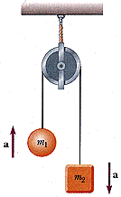
The tension T in the string and the weights of the two masses must be like:
- T > m₁g > m₂g
- T > m₂g > m₁g
- m₁g > T > m₂g
- m₂g > T > m₁g
- m₂g > m₁g >T

The velocity of an object as a function of time is shown in the graph below.

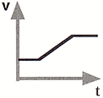

Which graph best represents the net force versus time relationship for this object?

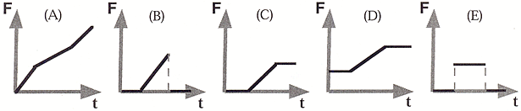

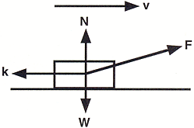
A person pulls a block (weight W) across a rough horizontal surface (friction force k) at a constant speed by applying a force F. The arrows in the diagram correctly indicate the directions, but not necessarily the magnitudes of the various forces on the block. Which of the following relations among the force magnitudes W, k, N and F must be true?

- F = k and N = W
- F = k and N > W
- F > k and N < W
- F > k and N = W
- none of the above choices

